**Homework 4**Lesson: Stochastic Discount FactorStudent Name: Zhao EnpingClass: G1

**Part 1: Minimum-Tracking-Error Frontier**

Plot the minimum-tracking-error frontier generated by the ten industry portfolios, with expected return deviation on the vertical axis and tracking error on the horizontal axis. Also plot the line starting from the origin that is tangent to the upper half of the minimum-tracking-error frontier, and calculate the information ratio and portfolio weights for the "tangency" portfolio.

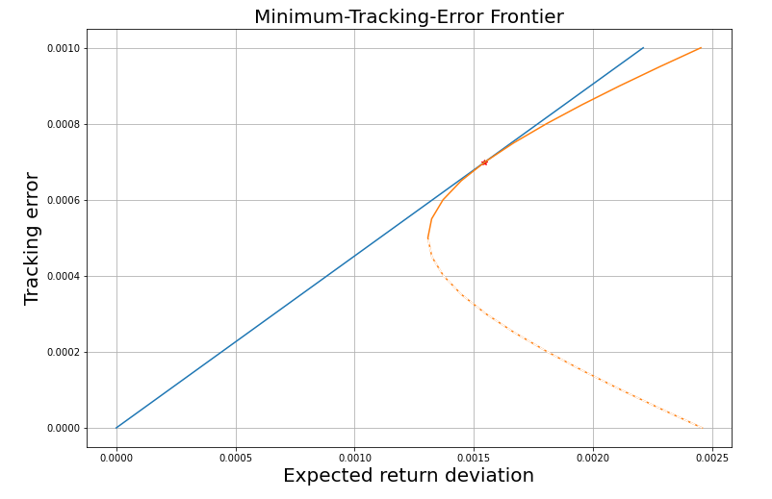

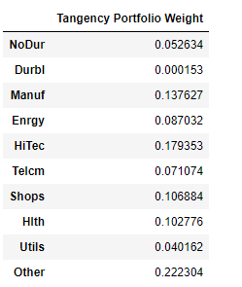

**Information Ratio**: 0.45248753961993204

**Part 2: Hansen–Jagannathan Bound**

Plot the ratio SD(M)/E(M) (on the vertical axis) vs 𝛾 (on the horizontal axis).

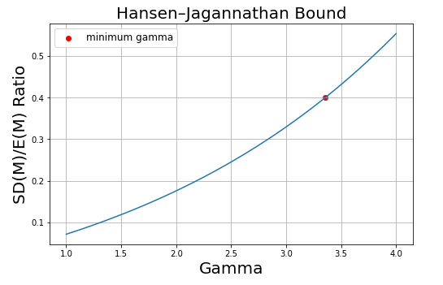

**Economic significance**:

The stochastic discount factor **M** represents investor’s intertemporal marginal rate of substitution (**IMRS**), also known as pricing kernel. Hansen–Jagannathan bound theory stats that the ratio of the standard deviation of a stochastic discount factor to its mean is greater than the Sharpe ratio attained by any portfolio, and the ratio is represented by y-axis. Gamma is the coefficient of risk aversion of investor (assuming investor has constant relative risk aversion) which is represented by x-axis. The graph represents the value of ratio (SD(M)/E(M)) at different value of coefficient of risk aversion. The minimum spot of Gamma for which the Hansen–Jagannathan bound is satisfied (SD(M)/E(M) > 0.4) is marked on the graph. According to Equity Premium Puzzle, If Gamma is below the minimum value, the sharp ratio/risk premium will be too low, which will not give an acceptable return for investor, therefore the Hansen–Jagannathan bound is only satisfied at the range whereby SD(M)/E(M) > 0.4.

**Appendix:**

